# Organizational Aims

Asanas is a yoga studio which specialize in organizing sessions of according to customer's satisfaction. Sessions such as beginners' yoga for legs, seated full Body Yoga,Happy Hamstring Class,Yoga for the Hips,Hatha Based Yoga and Asana Yoga Special. Our philosophy aims to discusses that we at Dharma Yoga enjoy a philosophy that satisfies both the most modern and ancient practicing of true Dharmic Yogi's.Wisdom is knowing we are all one. Love is what it feels like and compassion is what it acts like. With a team of young, creative, dynamic & dedicated professionals, we have pushed all areas of knowledge of yoga to new frontiers. We turn concept into reality and make our client satisfied. With over a decade of experience our knowledge and technical expertise are exceeded only by our passion for perfection because all the arts and sessions are well organized. Asana can help you learn upon the skills and enlightenment of yoga enthusiasts no matter how long or little you have been active and practicing. Our goal is to establish a long lasting connection with our clients and class participants who we'd like to navigate through the ups and downs life brings with a spiritual ease. We believe that each individual is unique, with its own capabilities and experiences. We also know that in order to deliver a successful session, you need good trainers and trainees that understands each individuals.

**Main objectives**

At Asanas our main objective is to expand your horizons with Dharma Yoga, join us and become a visionary. Furthermore, train your body, mind and spirit to focus on bettering yourself time and time again. Learn the teachings of the ancient practice from Yogi's around the world, be attach one with the earth.

For people who enjoys nature, we provide outdoor stretching to lessen the stress of a person by enjoying the nature and her sound and take in the beautiful surroundings with our “Yogi”.

We also focused on providing your private, groups and public sessions. Our therapy provides special effects to make our clients feel more enlighten, stress-free, healthy and finding inner peace. Our primary at Asanas is to promote yoga younger generations.to learn more about healthy lifestyles by joining our sessions.

**Branding Impression**

Asanas webpage is a professional branding impression because it can be useful for people to learn more about the various sessions that are held at Asanas. The website make people to choose a session of preference. We, Asanas have very high quality images and full information on our website for customers to choose their preferred session. We at Asanas have the experience and wisdom to improve upon the skills and enlightenment of yoga enthusiasts no matter how long or little you have been active and practicing. Our goal is to establish a long-lasting connection with our clients and class participants who we'd like to navigate through the ups and downs life brings with a spiritual ease. As a catalyst for positive encouragement, every year the Penang State Yoga Committee sends out awards to the best yoga studios in the south and we have been on the top three list for 4 years now. Our passion is to mainly guide non-profits, specifically those focused on youth empowerment, knowledge and health fitness for our clients to achieve new heights always.

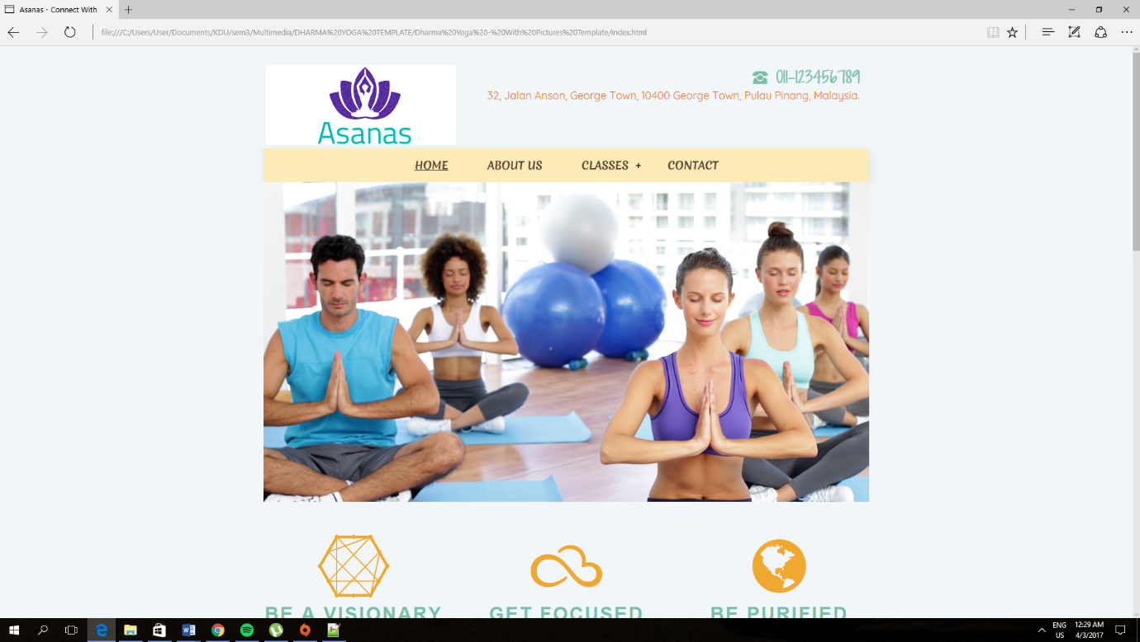This is the homepage of the website.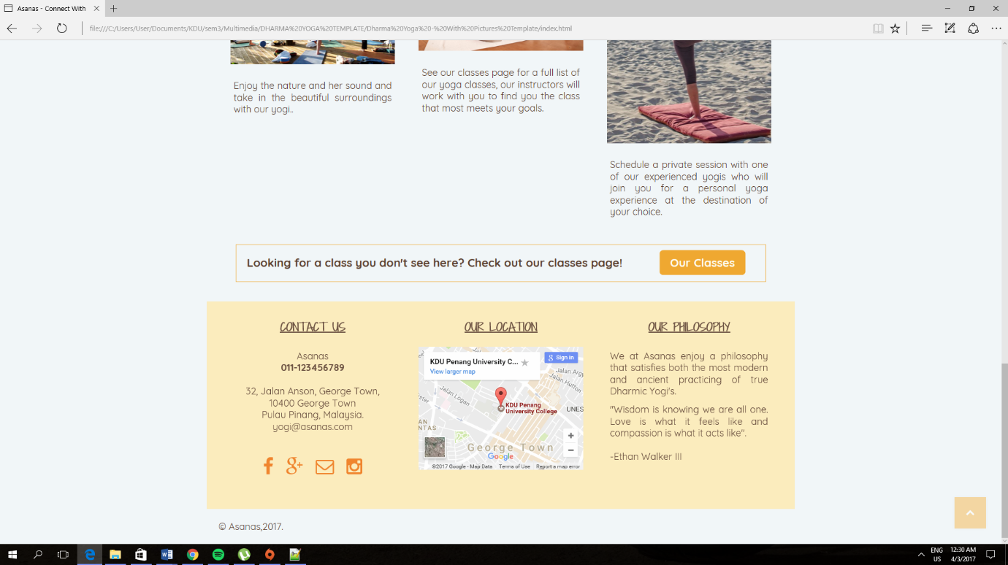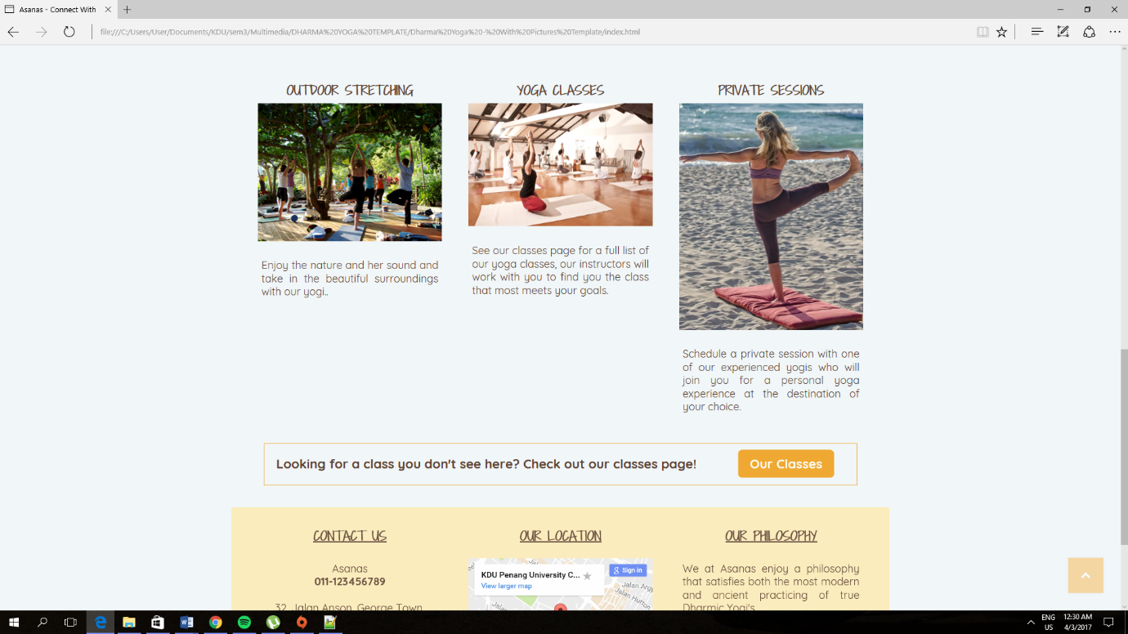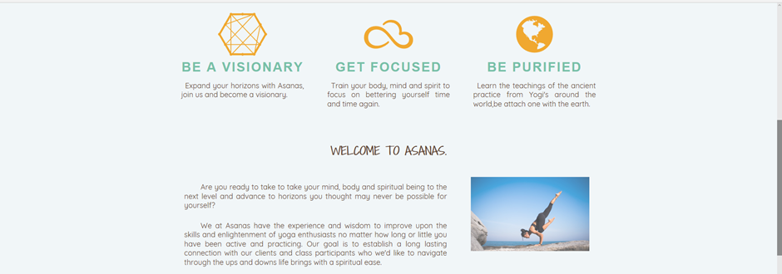

Each page has included with the social media applications link which are Facebook, Instagram and Google+ for customer to contact us. height. I have also included the location of the yoga studio situated with address and GPS coordinates.

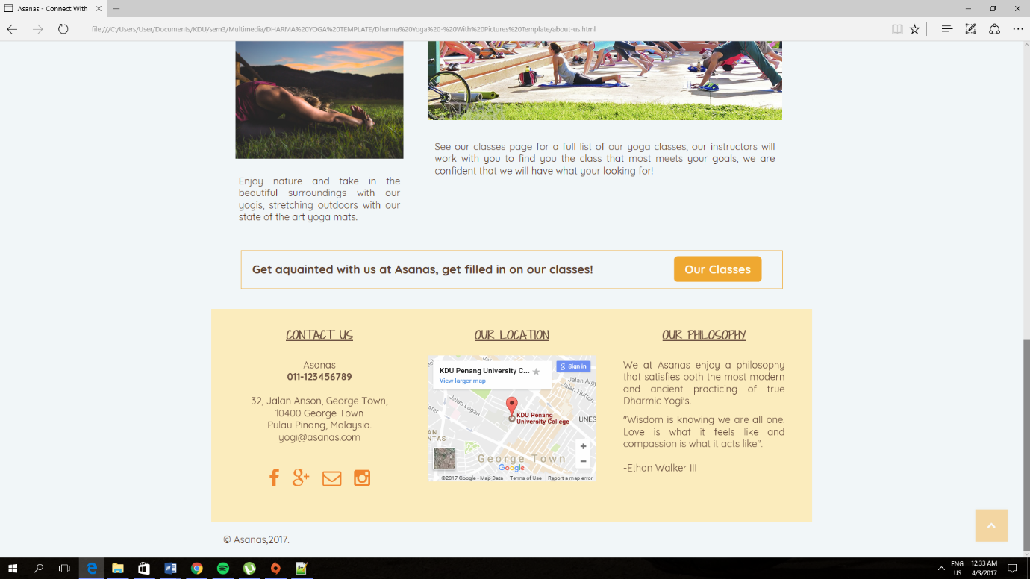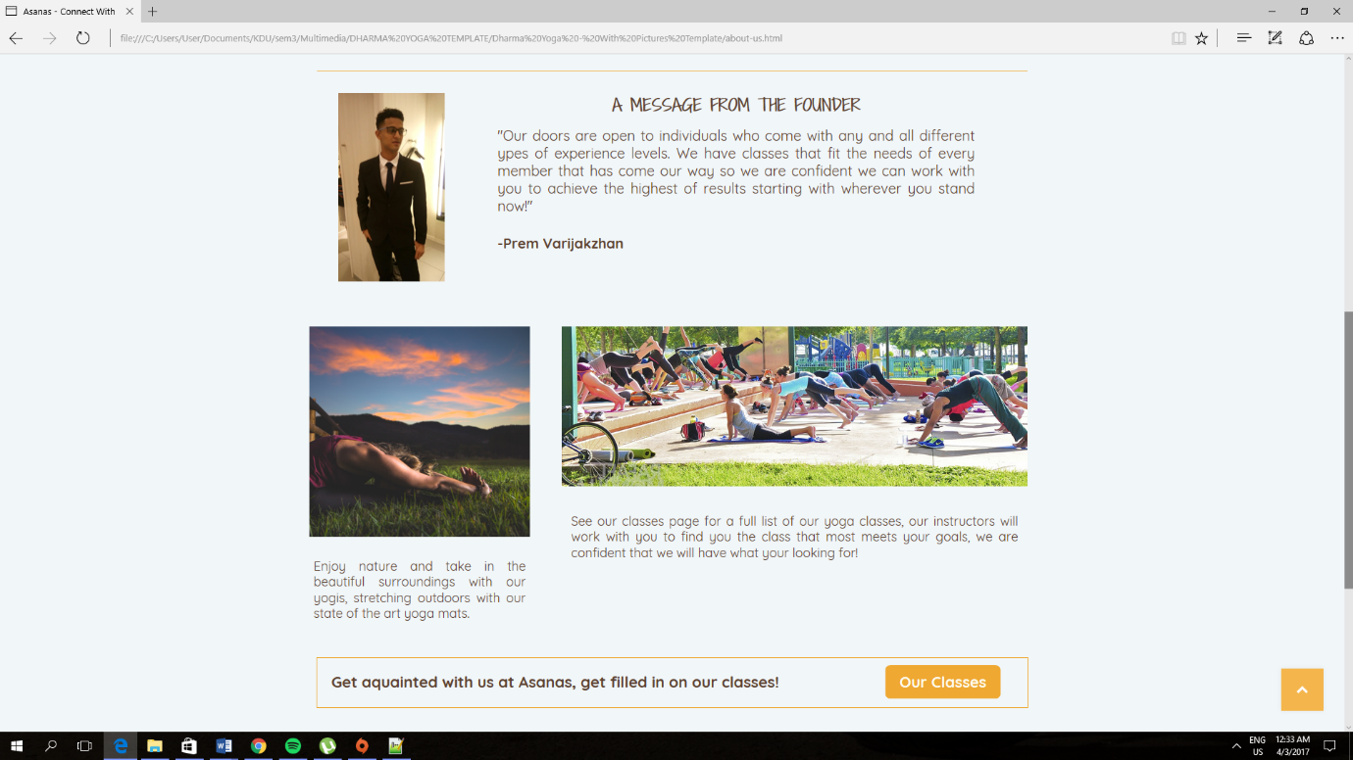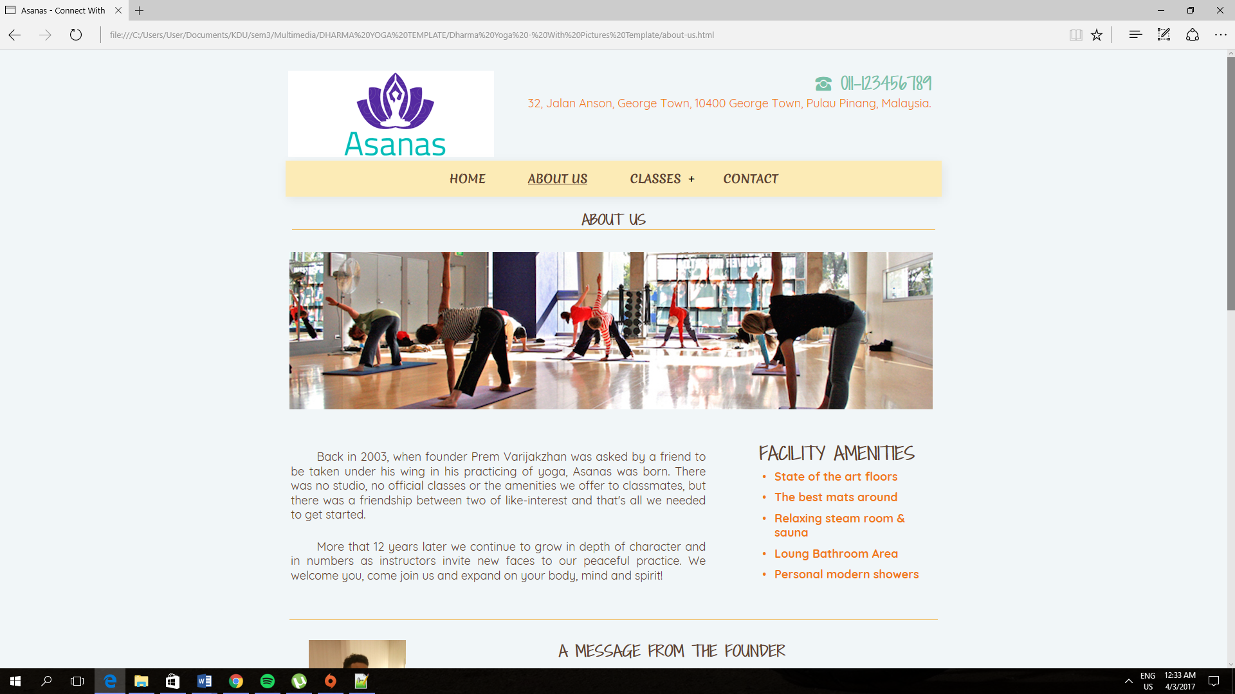

In this homepage, I made the about us section short and simple. The colour of the page is light to make the viewers easy to read and understand the contents.

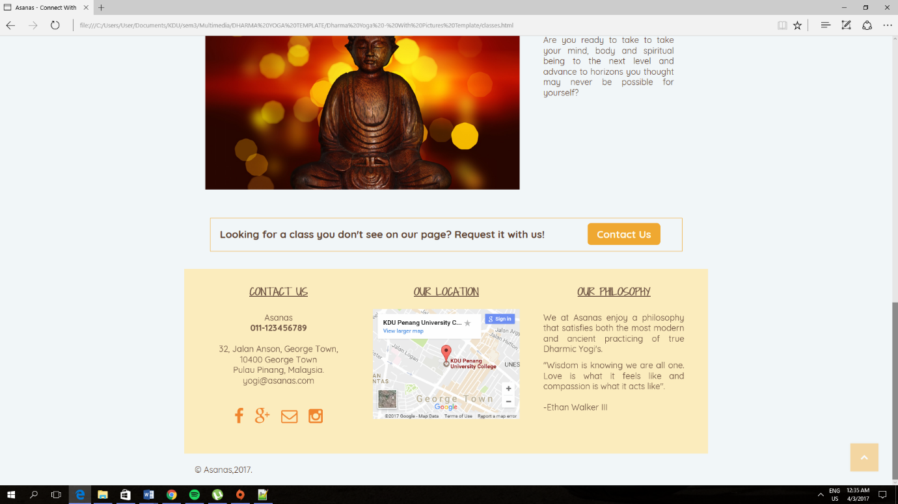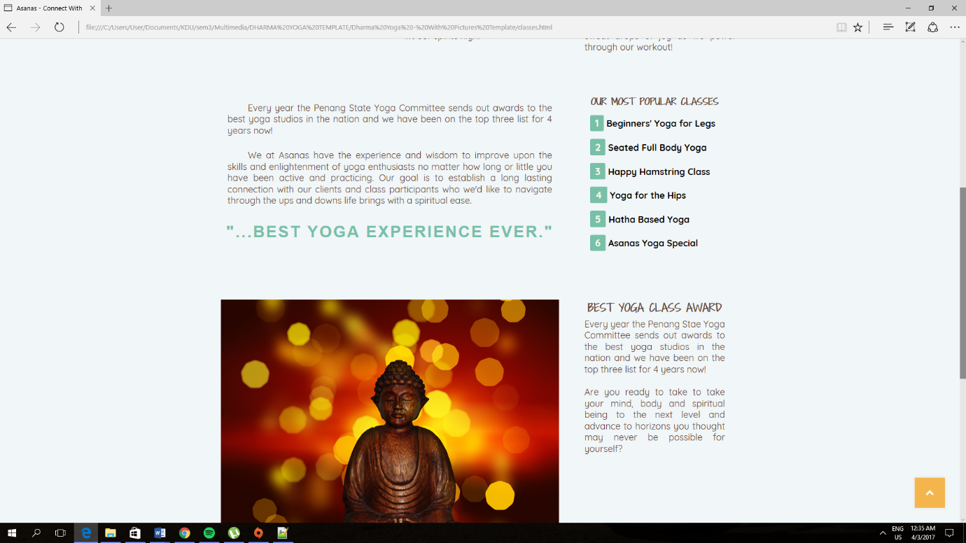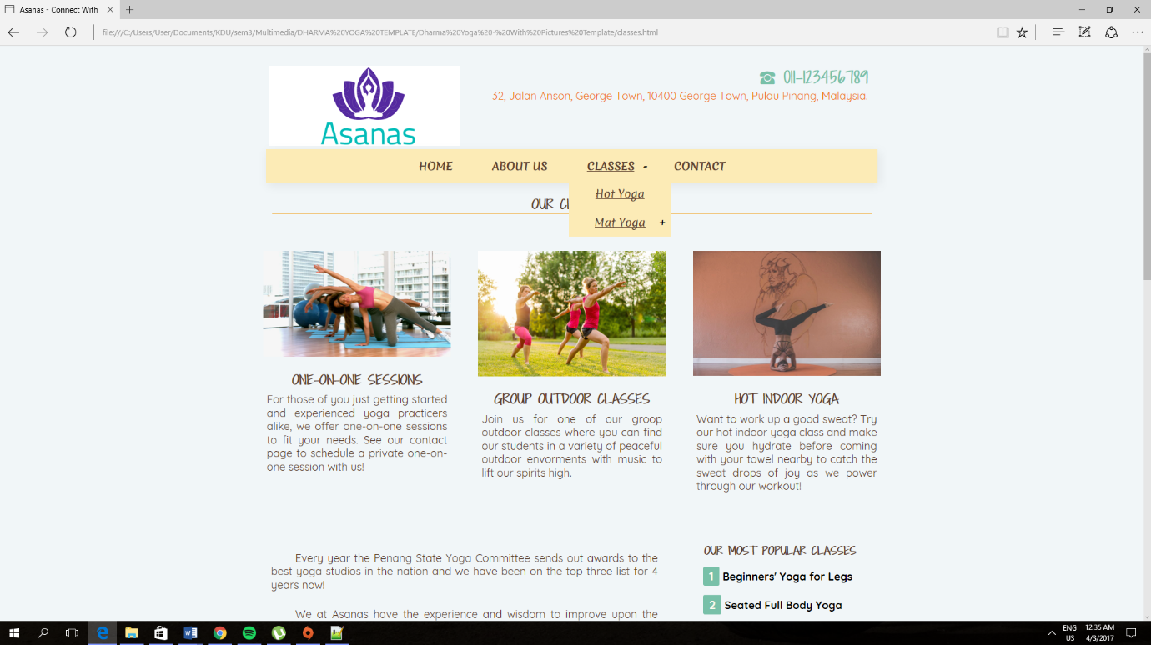I have also included the type of classes available so that customers can know what is available at the yoga studio.

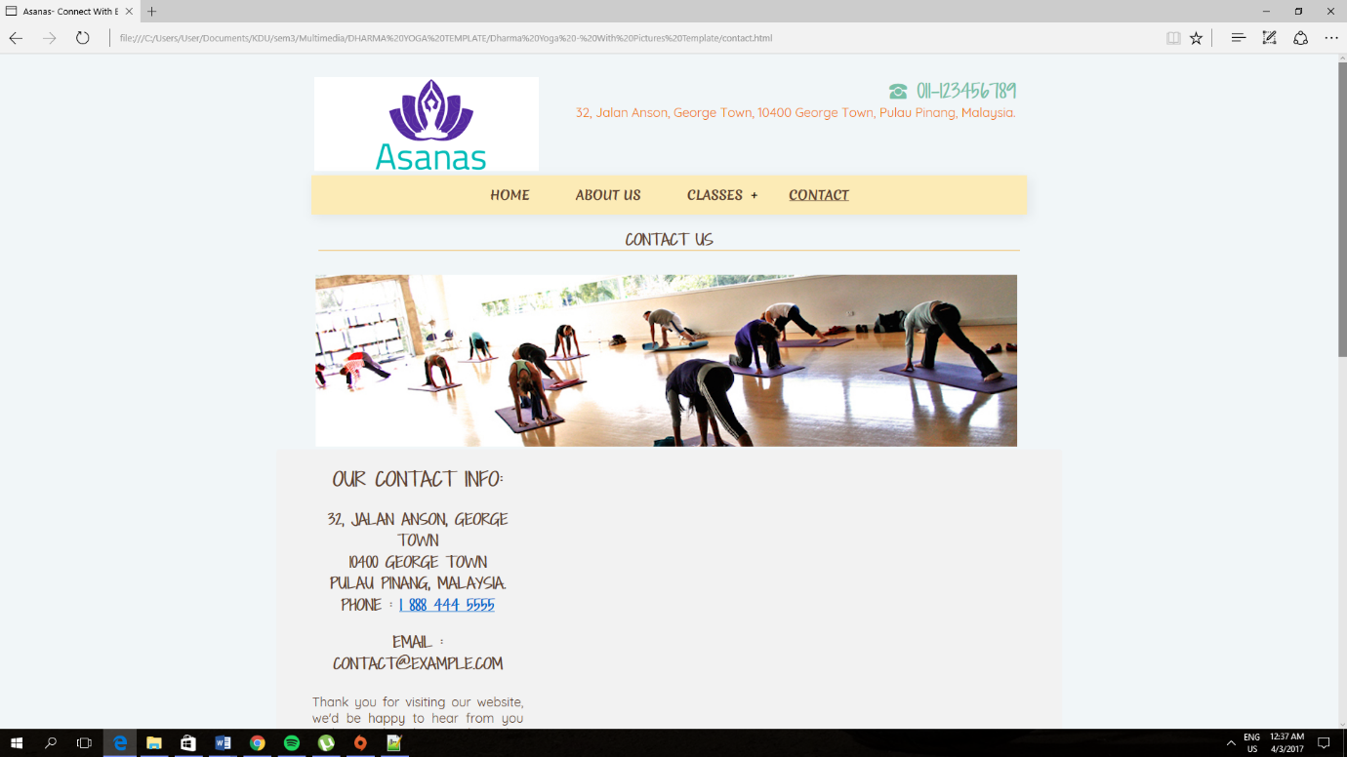

At last, there goes a feedback form for customer to comment about the design and their opinion on the feedback in order to improve their services on arts and event performance.